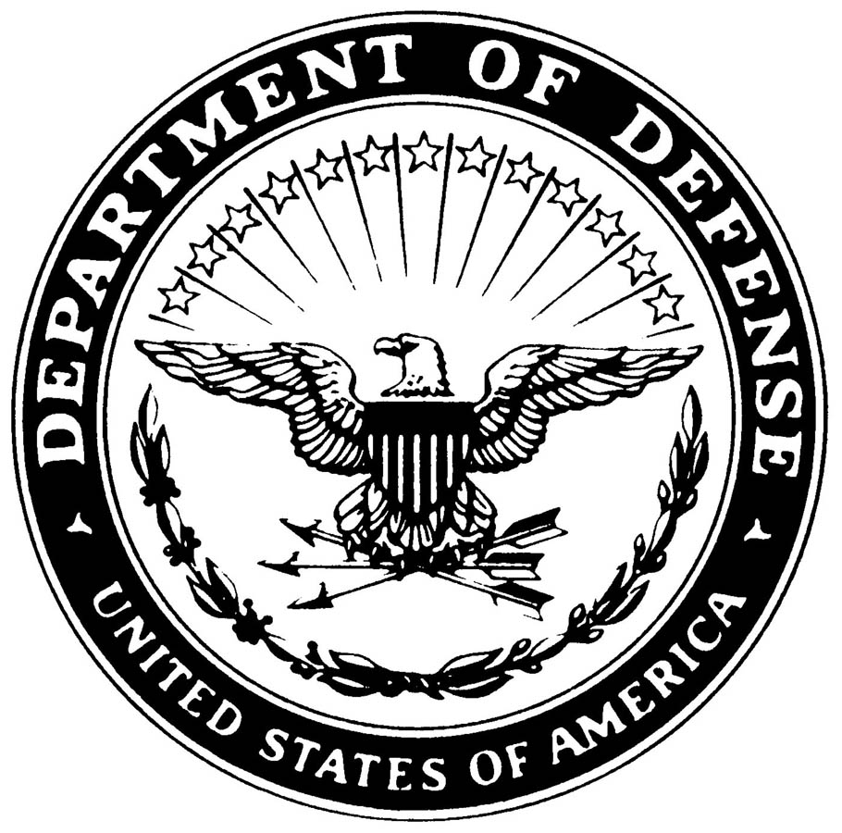**UNITED STATES MARINE CORPS**

MARINE AIR GROUND TASK FORCE TRAINING COMMAND

MARINE CORPS AIR GROUND COMBAT CENTER

BOX 788100

TWENTYNINE PALMS, CALIFORNIA 92278-8100

SSIC

Office code

(date)

POLICY LETTER X-XX

From: Commanding General

To: Distribution List

Subj: POLICY CONCERNING REQUESTS FOR SPECIAL DUTY ASSIGNMENTS

Ref: (a) MCO 5215.1K

Encl: (1) Financial Screening checklist

1. Purpose. To establish policy for Marines desiring to request special duty assignments.

2. Cancellation. Only use a cancellation paragraph if cancelling a previous policy.

3. Information. Reference (a) establishes procedures for Marines desiring special duties, i.e. Drill Instructor, Marine Security Guard, Recruiting, or School of Infantry Instructor. These special duty assignments are encouraged, however, the mission of the unit supersedes the desire of the Marine. The enclosure must be completed by all applicants.

a. Drill Instructor Duty. Marines requesting this duty will interview with the Sergeant Major.

b. Recruiting Duty. Marines requesting this duty will interview with the career planner for screening.

c. Marine Security Guard Duty. Marines requesting this duty will be required to complete a security investigation at the S-2 prior to submission.

d. School of Infantry Duty. Marines requesting this duty will see the career planner to set up an interview with the Sergeant Major, School of Infantry East/West.

4. Scope. In order to ascertain the duty to which an individual is best suited, and to ease the paperwork burden, the directions in the above paragraphs must be carried out prior to an actual request being submitted. This will ensure that Marines are totally prepared for the special duty requested prior to departing this unit.

DISTRIBUTION STATEMENT A: Approved for public release; distribution is unlimited. (Policy letters will be submitted for the installation commander’s signature only.)

5. Certification. (If necessary, this and other paragraphs can be utilized.)

C. P. CHELIOS

Distribution: A

Copy to: 6th Mar, 2d MarDiv

2

Policy Letter Guidelines

* The Policy Letter is written to provide the commander’s guidance on policy within a particular unit.
* Majority of format is based on standard letter (SECNAV M-5216.5) and Marine Corps directive (MCO 5215.1K).
* Title paragraphs as necessary to clearly convey the intent of the commander or establish the policy.
* Provide the information needed for instruction, but be concise.
* Annotate references as applicable.
* Enclosures are authorized and should be attached to the policy letter when published.
* Ensure that the designation line is at the top of each successive page. Policy letters are issued by chronologically and by calendar year (CY). Below is an example of the designation line for the first Policy Letter typed in CY 2014:

POLICY LETTER 1-14

* Policy letters should be signed by the commander due to the legal nature of establishing unit policy.
* It is recommended that the units maintain a “Policy Letter” file.